AUTH-004
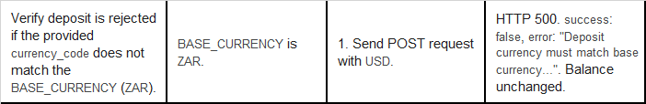
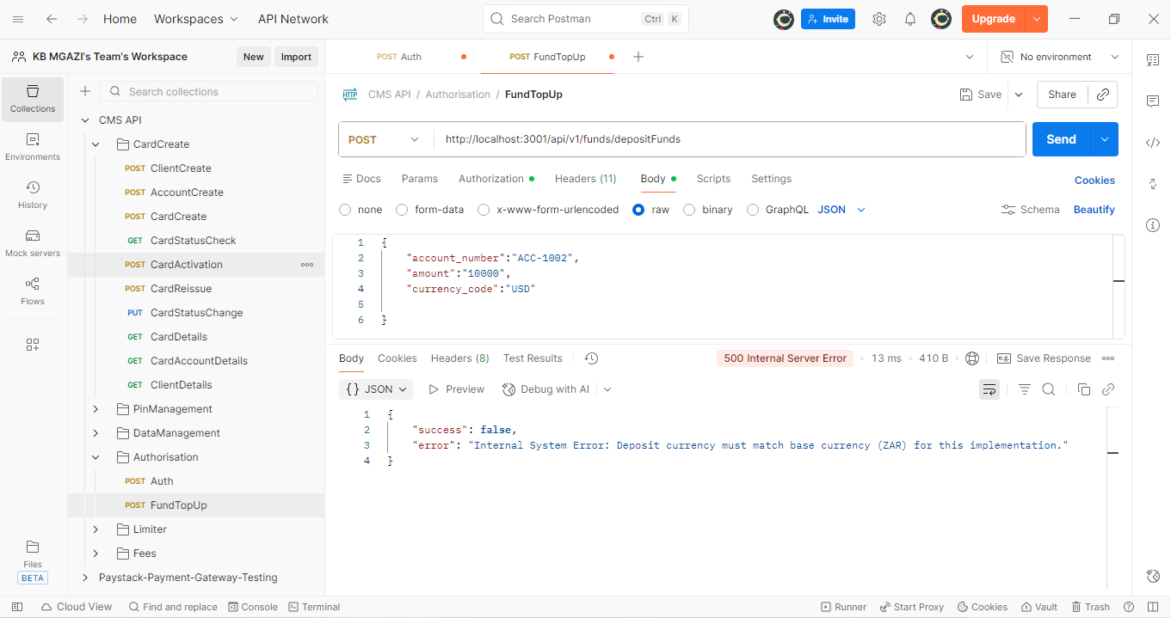
Request:
{
"account_number":"ACC-1002",
"amount":"10000",
"currency_code":"USD"

}
Response:
{
"success": false,
"error": "Internal System Error: Deposit currency must match base currency (ZAR) for this implementation."
}

